A report on data analysis of car collisions

By

Sourja Paul

# Business Problem

With increase in the number of cars on road there has been an increase in traffic which has led to increase in road accidents. Mishaps due to car accident are a major concern for both the law enforcers and the riders behind the wheels.

As data analyst we can address this problem by designing a predictive model to be used by traffic regulators and common people to understand what conditions are the major reasons for the road accidents.

To solve this business problem we need to have previous data set about car collisions having specification on various attributes like the road condition, the weather and the car condition. This will help us in determining the key factors leading to these accidents. The data will help us in designing a predictive model that will help in providing recommendations on the basis of prevailing factors and minimize the quantity of car collisions.

# Data collection and wrangling

Seattle Police Department (SPD) has been collecting detailed data about cars collisions. It will be used for developing model that allows to determine locations, weather conditions, days of week, time of day and other factors that are helpful for car collisions prediction.

The dataset is available at <https://s3.us.cloud-object-storage.appdomain.cloud/cf-courses-data/CognitiveClass/DP0701EN/version-2/Data-Collisions.csv>

File with metadata is available at<https://s3.us.cloud-object-storage.appdomain.cloud/cf-courses-data/CognitiveClass/DP0701EN/version-2/Metadata.pdf>

The data has 38 variables and 194673 records. The dependent/target variable for this dataset is SEVERITYCODE. It has only two values and our analysis and model design will revolve around this variable only.

|  |  |
| --- | --- |
| **SEVERITYCODE** | **SEVERITYDESC** |
| 1 | Property Damage Only Collision |
| 2 | Injury Collision |

From the list of remaining 37 variables, 8 variables are chosen for independent variables.

|  |  |
| --- | --- |
| **Variable Name** | **Variable Description** |
| ADDRTYPE | Address type |
| COLLISIONTYPE | Type of collision |
| UNDERINFL | Whether the driver was under the influence of alcohol |
| PEDCOUNT | Number of pedestrians injured |
| INCDATE | Date of collision |
| WEATHER | Weather during collision |
| ROADCOND | Road condition during collision |
| LIGHTCOND | Light condition during collision |

We will do data visualization with these variables to find out how much impact they have on SEVERITYCODE and then design our predictive model based on the selected variables among this.

For data wrangling we first filter out the missing data and delete those data. The revised dataset have 187504 records. The data for UNDERINFL was amended to make it in sync with either N for No or Y for Yes. From INCDATE we filtered out the days and clubbed Monday-Thursday as WORK (workday) and Friday-Sunday as WEND(weekend).

# Data Visualization

Bar charts for normalized independent variables were plotted to identify those variables that varies for different SEVERITYCODE.

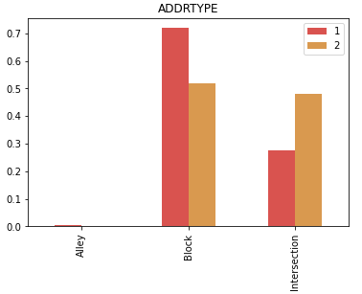

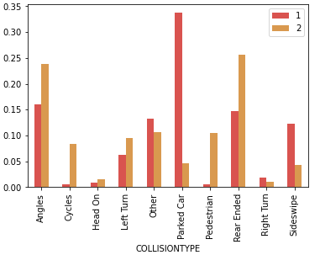

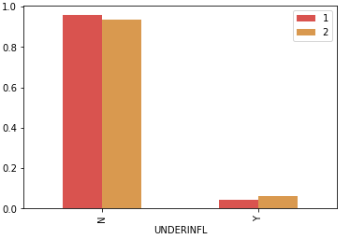

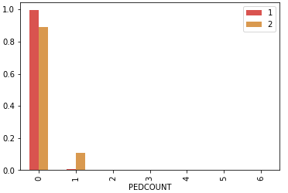

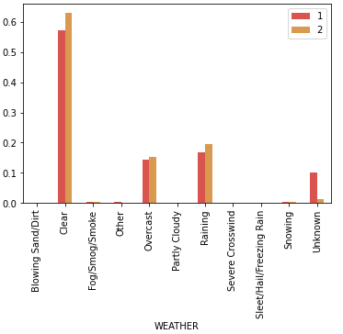

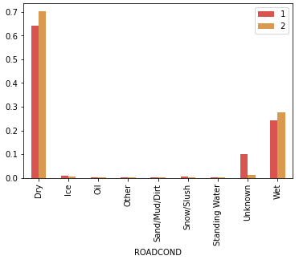

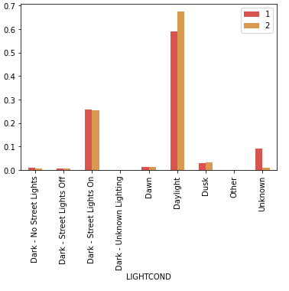

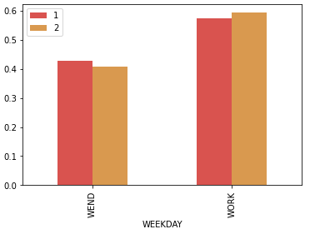

# Predictive Modelling

From the above bar charts we can deduce that UNDERINFL and PEDCOUNT doesn’t have much impact on SEVERITYCODE, a little less than 100% were not UNDERINFL and 0 number of Pedestrians injured. We select the other remaining six variables for our predictive modelling but first we factorize our data for easy modelling.

A snapshot of the factorised data

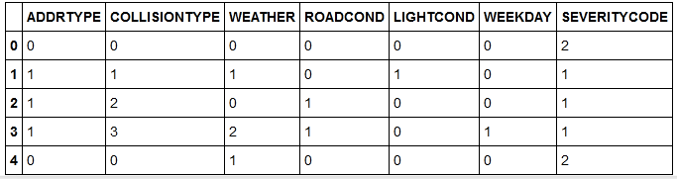

The objective of the model is to predict the severity code of the collision based on the available data. Two classification model were used and the one with better accuracy will be selected for this dataset.

Dataset was divided into two sets, training (80%) and test (20%).

KNN Algorithm was run first and we found k =10 has the best accuracy.

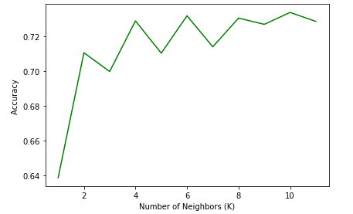

Then we implemented Logistic Regression.

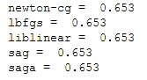

We compared the Jaccard score , F1 score and the average of the two values.

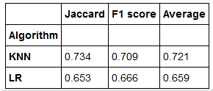

Based on the average value KNN algorithm model will be our best choice.

# Discussion

The KNN algorithm thus confirms that the independent variables ADDRTYPE, COLLISIONTYPE, INCDATE, WEATHER, ROADCOND and LIGHTCOND does have an uimpact on the severity of car collision. Most collisions take place at intersection and at block. Parked cars are the major type of collisions and majority collisions happened on work days during the day. So a better traffic management plans on car parked at roads near intersection and blocks with more focus during office hours when the volume of cars on road is at large might lead to decrease of car collision.

# Conclusion

In this study the emphasis was on to identify the variables that impact car collision and filter out the unwanted data. The variables were then put to a data visualization test from where we selected the variables really impacted the severity based on bar graphs. The data was factorized and put under two classification algorithm KNN and Logistic Regression and based on the average score KNN was selected.